# DL Lab 08

## Question 1: Markov Decision Process and Q-Learning

1. 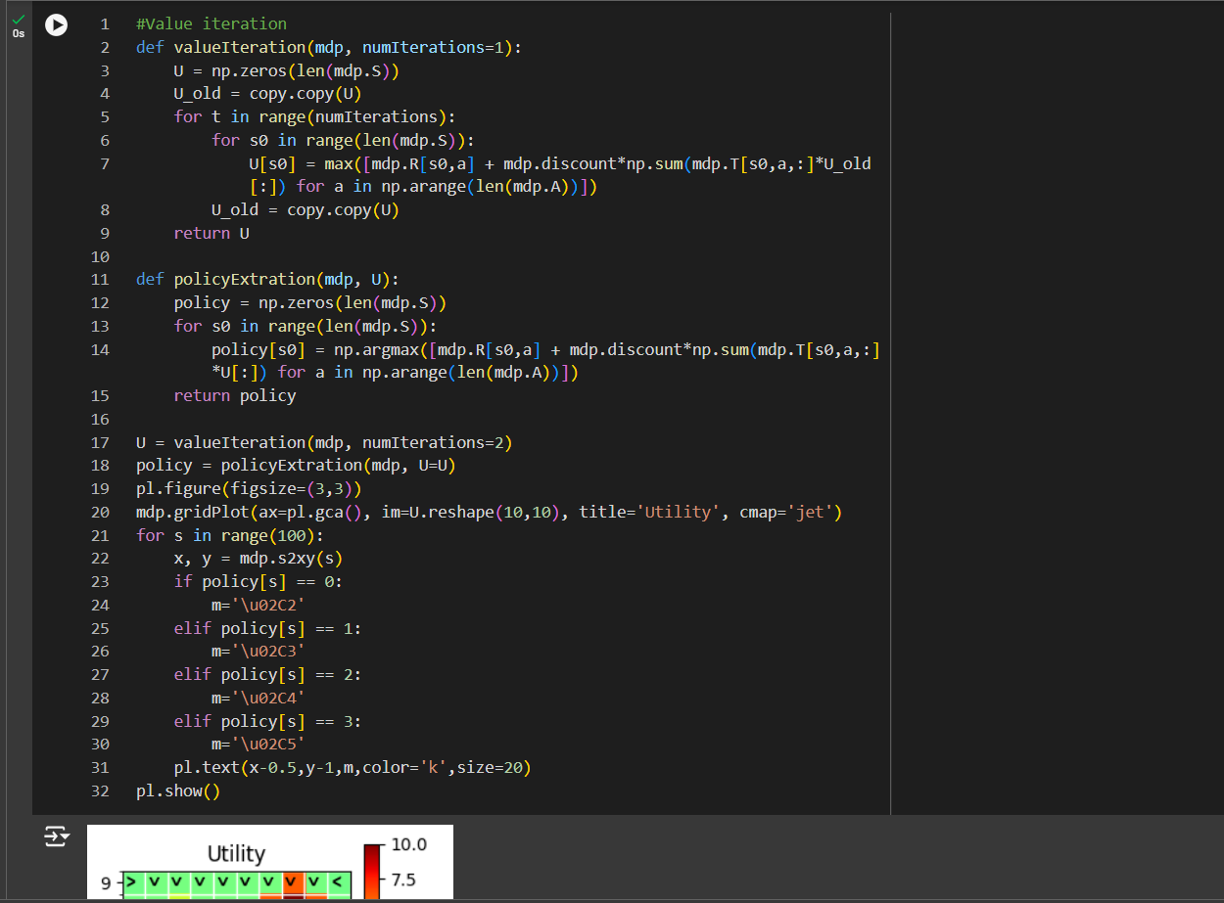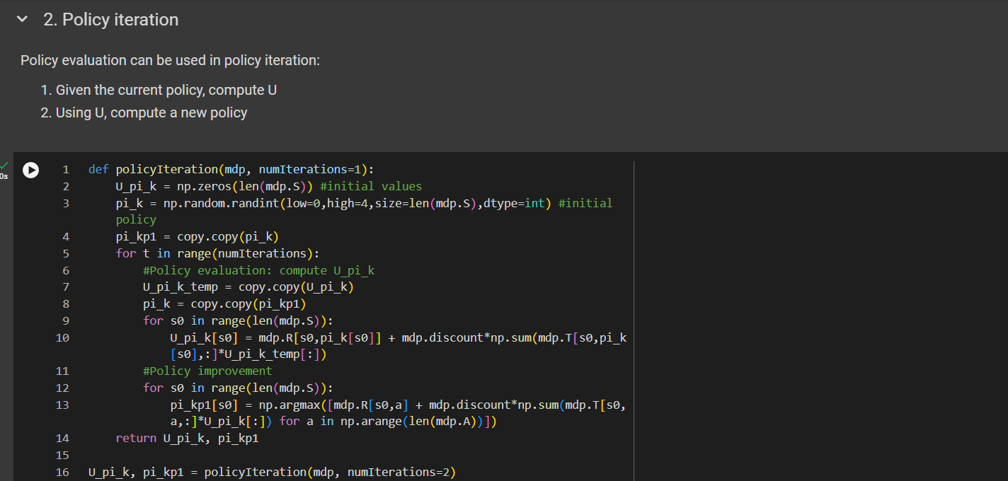Policy Evaluation

## Question 2: Model-Based vs Model-Free Reinforcement Learning

### **Difference Between Model Based and Model Free Algorithms**

|  |  |
| --- | --- |
| Model Based Algorithms | Model Free Algorithms |
| Learns a model of the surroundings explicitly | Learns via firsthand encounter with the environment rather than from a model of it. |
| Usually converges more quickly when the model is precise. | Slows convergence, particularly in intricate settings. |
| Makes use of the acquired model to plan and simulate activities, enabling foresight | Without prior planning, gains knowledge through direct trial & error. |
| Because it can plan by simulating multiple probable outcomes, it is more sample-efficient. | Less sample-efficient and more dependent on environmental interactions for improvement |

## Question 3: Introduction to Deep Q-Learning (DQN)

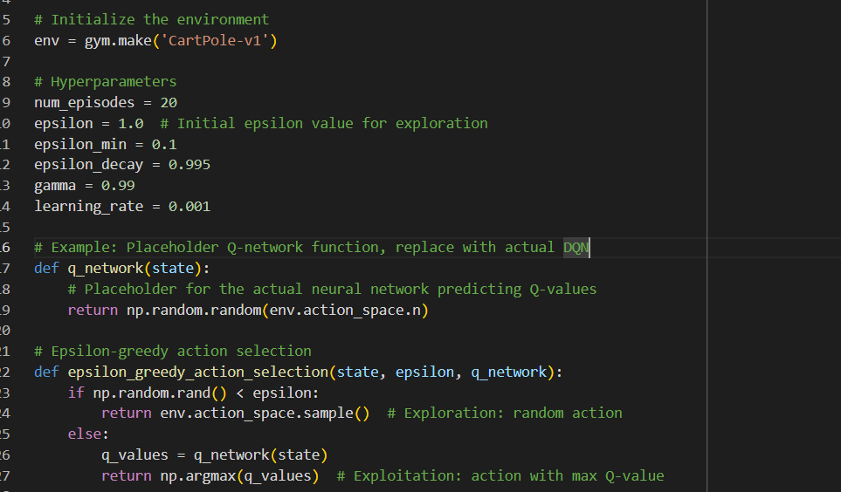 For Epsilon Val: 0.1

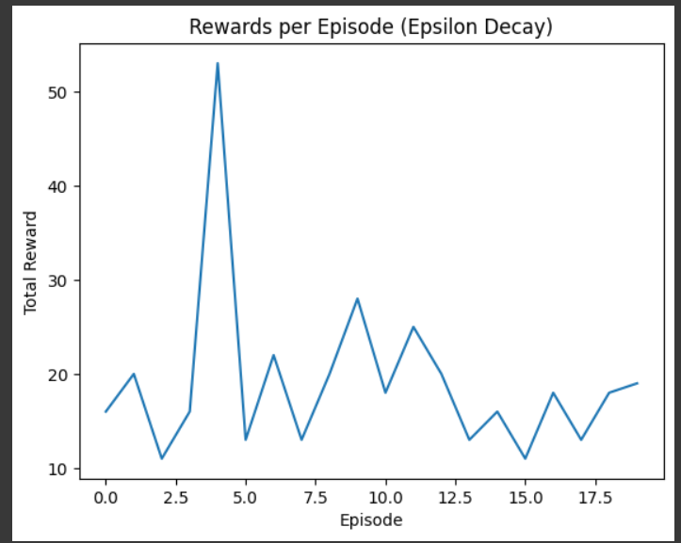

For Epsilon Value 0.5

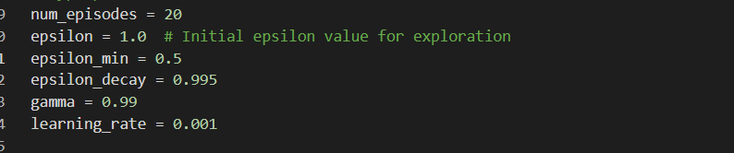

Foe Epsilon Value 0.9

# IT21280474_Gridworld.ipynb Changes

